Inspection control in poultry meat.

The improvement of the production standards in a company leader in the poultry meat market: the role of the Competent Authority.

Il miglioramento degli standard produttivi in una azienda leader nel settore delle carni avicole: il ruolo dell’Autorità Competente

Gramenzi Monica^{1*}, Guerrieri Oana², Di Pancrazio Emidio³, Pennisi L. ¹, Vergara Alberto⁴

* Corresponding author. Tel: (+39) 347 3111830; E-mail: gramenzivet@gmail.com
(¹)Scuola di Specializzazione in Ispezione degli Alimenti di Origine Animale “G.Tiecco”, Università degli Studi di Teramo, Teramo, Italia
(²) Responsabile Servizio Igiene Alimenti O.A. -Ausl 4 Teramo
(³) Coordinatore e Responsabile Tecnico dei Laboratori di Assicuraz. Qualità del gruppo Amadori
(⁴) Direttore Scuola di Specializzazione in Ispezione degli Alimenti di Origine Animale “G.Tiecco” Università degli Studi di Teramo

* Corresponding author. Tel: (+39) 347 3111830; E-mail: gramenzivet@gmail.com
(¹)Post graduation school for inspection in animal origin food “G. Tiecco”, University of Teramo, Teramo Italy.
(²) Managing Director Food Inspection O.A. -Ausl 4 Teramo
(³) Coordinator and technical Manager of Quality Assurance Laboratory for Amadori Group
(⁴) Director of the post graduation school for inspection in animal origin food “G. Tiecco”, University of Teramo, Teramo Italy.

Abstract
The object of this study was to evaluate, in a company that is leader for the production of poultry meat, the effects on corporate manufacturing standards of the combined action between the Official Veterinary Controls and the Food Business Operator. For this purpose, the corporate documentation have been examined (inspection reports and audits of Official Veterinary Controls and data obtained by self-control procedures) on a four year period between 2008 and 2011. The results obtained showed that, despite the application of specific procedures by the Food Business Operator, the Competent Authority has observed a number of non-compliances, grouped into four main areas: cleaning and disinfection, maintenance in the plant, staff training, management of Animal by-Products. The immediate response of the Food Business Operator for the resolution of the non compliances resulted in a significant overall improvement in hygiene and safety of products and processes, a gradually reduced number of non-compliance reports, a decrease of all microbiological parameters and the extension of products’ shelf life.

Riassunto
L’obiettivo del presente lavoro è stato quello di valutare in una azienda leader nella produzione di carne avicola, gli effetti sugli standard produttivi aziendali della azione combinata tra i Servizi Veterinari e l'Operatore del Settore Alimentare (OSA). Allo scopo si è proceduto all’analisi della documentazione aziendale (rapporti ispettivi e di audit dei Servizi Veterinari, e dati ottenuti in autocontrollo) relativa al quadriennio 2008-2011. Dai risultati ottenuti è emerso che, nonostante l'applicazione di precise procedure interne da parte dell’OSA, l’Autorità Competente ha rilevato un certo numero di non conformità, raggruppabili in quattro macro aree principali: pulizia e disinfezione, manutenzione degli impianti, formazione del personale, gestione dei Sottoprodotti di Origine Animale (SOA). La pronta risposta dell’OSA per il soddisfacimento dei requisiti non conformi ha permesso di ottenere un significativo miglioramento generale in materia di igiene e di sicurezza dei prodotti e dei processi, con un numero via via minore di verbali di non conformità, un decremento di tutti i parametri microbiologici e l'estensione della shelf life dei prodotti.
Key words – Official Control, Poultry, Production standards.

Introduction
In recent years, under the impact of significant changes to the relevant community legislation and rapid changes in the balance of the market, the organization and structure of the poultry production chain has experienced profound changes. The leading industries have had to implement and maintain highly effective Food Safety Management Systems (FSMS) able to sustain high production rates and to ensure adequate shelf life at large volumes of highly perishable product.
The high degree of corporate maturity results in the correct implementation of procedures based on the principals of hazard analysis and critical control points (HACCP) and other procedures to verify compliance with hygiene, in full respect of binding regulations, and very often voluntary. The role of the Competent Authority in these evolved realities remains central in the course towards the optimization of the Food Safety Management System. For the purpose it was considered interesting to evaluate over a period of four years, the role of Veterinary Services in a leading company in the sector and the margin of improvement that the competence of the Authority in one hand, and the awareness of the importance of invest in food safety by the Company on the other, in a spirit of active cooperation, has allowed to achieve.

Materials and methods
It was evaluated in the 2008-2011 period, the activity of Official Control held constantly by the Hygiene Veterinary Service for Animal Origin Food Ausl of territorial competence in a leading company in the production of poultry meat. For this purpose, the documents for all activities have been analysed, considering the inspection reports, audit reports, and the results of the microbiological analyzes provided in the sampling plan of the manual of corporate self-control. Specifically have been subject of control areas of the slaughter and cutting, with the relevant production lines. The research of microbiological parameters of skin samples and environmental pre-operative, took place using validated methods below: Total mesophilic charge (CMT): Uni En Iso 4833:2004; Total Coliforms: Uni En Iso 4832:1991; Escherichia coli: Uni En Iso 16649-2:2001; Salmonella spp.: Uni En Iso 6579:2008; Coagulase positive Staphylococci: Uni En Iso 10984-2:2002; Pseudomonas spp.: AFNOR V04-504-April 98; environmental swabs: UNI EN ISO 4833:2004 ISO 18593:2004-. In 2011, shelf life tests were conducted by the Company on different types of fresh produce packed in trays with permeable plastic film, temperature of + 4 ° C (storage temperature in the legislation) and + 8 ° C (temperature presumably present in the home).
Total of 7 samples were tested.

Results
The major non-conformities identified during the inspection activity (subject to inspection reports) were divided into the following groups: area cleaning and disinfection (the correct execution of a protocol for cleaning and disinfection is difficult to control especially in “dirty” areas and for the particular activity); structure maintenance area, plant and equipment (submitted daily to a high degree of wear and sometimes obsolete); staff training area (especially hygiene and correct information at all levels); area management of animal by-products (ABP). The results of microbiological samples on the skin to search for CMT, Total Coliforms, E. coli, coagulase positive are shown in Table 1 and the results of Salmonella spp are shown in Table n. 2 Figure n. 1. The results concerning the environmental swabs for the detection of CMT are shown in Table n. 3 and Figure n.2. The results of the tests of shelf life, (comparison between data collected in 2011 and those for the year 2008), are shown in the tables n. 4 and 5 and in Figures n. 3 and 4.

Discussion and conclusions
In the period under investigation the Official Veterinary of the Local Health Unit of competence, highlighted several non-compliance, as shown by the numerous inspection reports issued. The company has quickly turned to the satisfaction of the requirements, taking into account the requirements received not as a burden but as an opportunity for improvement and promoted:
• the implementation of proper sanitation procedures;
• the start of maintenance works and structural renewal;
• the reduction of cross-contamination through functional enhancements and appropriate interventions training of skilled workers;
• the introduction of major technological innovations.
The objective achieved has been an improvement of the 'efficiency of the activities with the reduction of problems related to the four macro-areas identified as the most sensitive (cleaning and disinfection, maintenance of plant and equipment, staff training, management of SOA). This improvement is evidenced by the reduction in the number of inspection reports, and then the non-compliance, as well as by the gradual lowering of the level of severity and importance of these. Also microbiological parameters tested have undergone major declines. The improvement of hygienic conditions of processing has also reduced the level of contamination by important pathogens such as Salmonella. Since 2011 the company has decided to include in its plan of self-control as a method of verification of the hygienic production and processing systems, a specific procedure concerning the evaluation of shelf life of the products. The data obtained from the survey carried out systematic, random compared to those obtained in the absence of a specific operating procedure for the year 2008, have revealed that the effectiveness of the interventions also had a favorable outcome on the final quality of the product, increasing the conservative estimated average life of 12 days, an additional two days. In conclusion, as you know, under Reg Ce 852/04, the primary responsibility for food safety is entrusted to the Operator of the Food Industry. The mere compliance with regulations, while adequate for the marketing of finished products, it is often limiting and certainly not very rewarding for the manufacturer. Embark on a path of growth to quality is instead a much more complex and ambitious goal to reach, but far more rewarding over time. In this perspective, the Competent Authority has a central role to support and address. Activity focused and continued in accordance with specific objectives and fixed time periods (frequency, number, programming) are essential to engage with the OAS a relationship of respect and trust. It 's just from the good collaboration between the two main actors in the food chain, being fully aware of their active role that rise that drive to continuous improvement that is essential to the goal of food security in a production system effectively and efficiently.

Bibliography
Pisanello D., C. Biglia, Pelican C. 2010 Guide to legislation on veterinary
PV PO P15 Procedure official control in poultry slaughterhouse with attached meat cutting and storage (before ed.15/03/2003 rev. 2 of 15/03/2011)-Quality Manual SVIAOA Ausl 4 (TE)
Regulation (EC) n. 852/2004 (2004) on the hygiene of foodstuffs (Official Journal of the European Union, L 139, 30/04/2004).
Regulation (EC) n. 854/2004 of the European Parliament and of the Council of 29 April 2004 laying down specific rules for the organization of official controls on products of animal origin intended for human consumption (Official Journal of the European Union L 139 of 30 April 2004).
Regulation (EC) n. 2073/2005 of 15 November 2005 on microbiological criteria for foodstuffs (OJ EU No L 338 of 22 December 2005).
Tantillo G.M. 2001 The hygienic production of meat
Vergara A., Festin AR, Di Ciccio P., L. Pennisi, M. Conter, C. Costanzo, A. Ianieri - The management of domestic refrigeration: characteristics sanitation of refrigerators of Central and Northern Conference AIVI 2,009

Table 1: Microbiological parameters relative to samples of chicken skin.
SKIN
YEAR | Q.ty sample | CMT  log ufc/g | Coliformi  log ufc/g | E coli  log ufc/g | STF  log ufc/g
2008 | 9 | 6,46 | 3,49 | 3,01 | 2,14
2009 | 47 | 6,99 | 3,11 | 3,26 | 2,25
2010 | 54 | 4,79 | 2,33 | 2,26 | 1,66
2011 | 51 | 4,64 | NA | NA | NA

Table 2: Salmonella spp in samples of chicken carcass skin.
Skin
YEAR | Q.ty samples |  | Salmonella(positive) |  | %
2008 |  | 255 | 66 |  | 25
2009 |  | 220 | 30 |  | 13
2010 |  | 260 | 25 |  | 9
2011 |  | 210 | 17 |  | 8

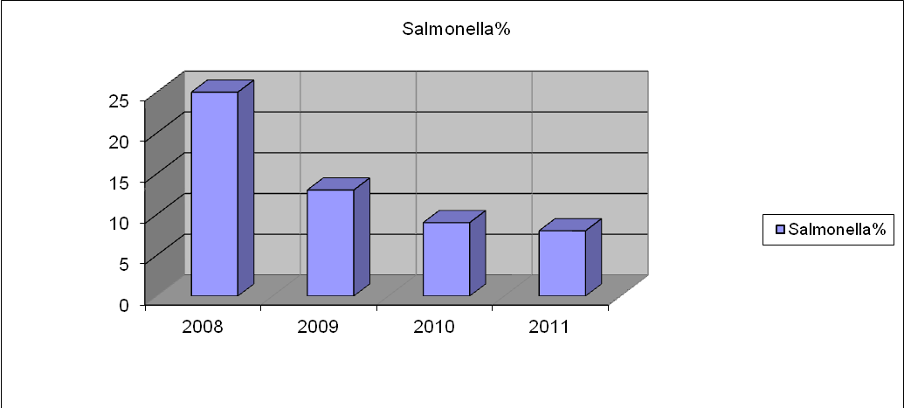
Figure 1: Salmonella spp (% positivity) in samples of chicken carcass skin.

Table 3:CMT given in log ufc/cm² in pre-operative environmental swabs.
 |  | Q.ty  Samples | CMT
2008 |  | 413 | 3,42
2009 |  | 606 | 3,05
2010 |  | 621 | 1,85
2011 |  | 643 | 1,26

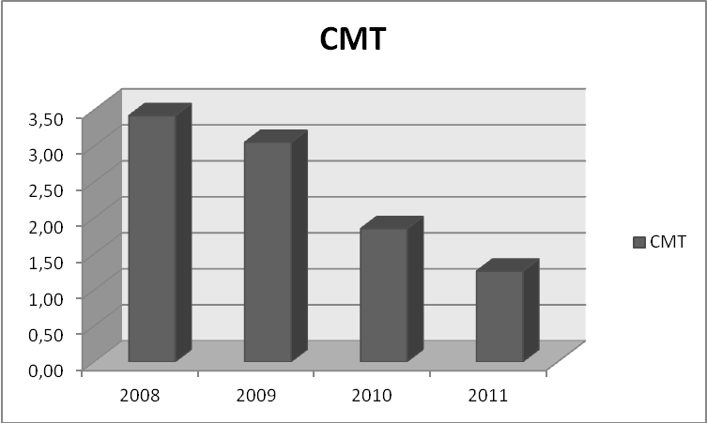
Figure 2 : CMT in pre-operative environmental schwabs.

Table 4: Shelf life tests carried out in years 2008 and 2011, relative to micribiological parameters CMT, E.coli, Pseudomonas given in log ufc/g (T= + 4°C).
 | Q.ty samples | CMT | Escherichia Coli | Pseudomonas
2008 | 13 | 8,35 | 2,79 | 8,83
2011 | 7 | 5,93 | 1,00 | 5,05

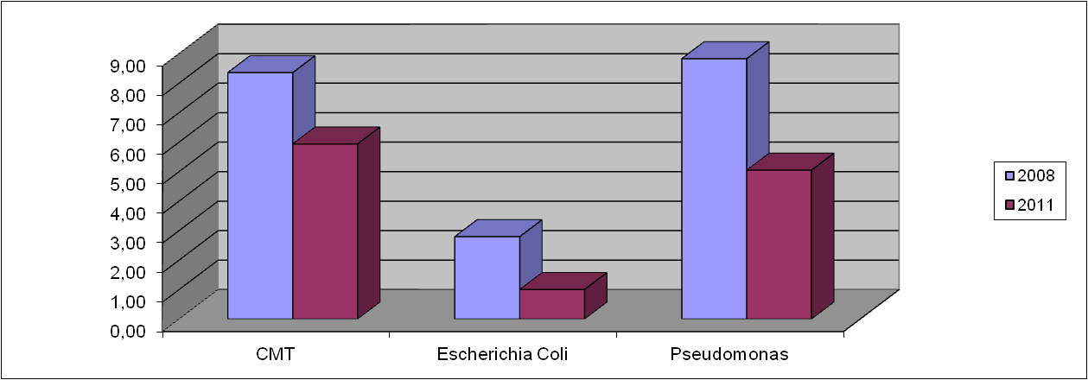
Figure 3 : Shelf life of fresh products packed in container with permeable plastic wrap, relative to microbiological parameters CMT, E.coli e Pseudomonas given in log ufc/g.

Table 5: Shelf life tests- comparison between the values of microbiological parameters (CMT, E.coli e Pseudomonas given in log ufc/g) tested at different temperatures (T= + 4°C - +8°C).
 | Q.ty samples | CMT | Escherichia Coli | Pseudomonas
2011 a 4°C | 7 | 5,93 | 1 | 5,05
2011 a 8°C | 7 | 8,66 | 2,86 | 7,46

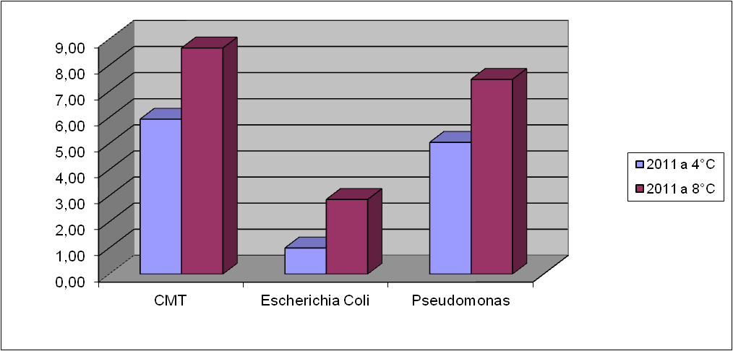
Figure 4: Shelf life tests- comparison between the values of microbiological parameters (CMT, E.coli e Pseudomonas given in log ufc/g) tested at different temperatures (T= + 4°C - +8°C).

